
  NAME:
  TEACHER:

MATHEMATICS
Year 9 5.2
Yearly Exam
2026

Instructions  1. Reading time: 5 minutes  2. Working time: 90 minutes  3. Attempt all questions  4. Show ALL working where needed  5. A calculator is permitted |  | Sections and Marks
  Section 1 - Data | /25
  Section 2 - Surface area and volume | /24
  Section 3 - Mixed Topics | /21
  Total marks | /70

 | Section 1: Data
 | Multiple Choice: |  | Mark
1 | Which of the following is numerical continuous data? |  | 1
  A. The number of goals in a hockey match | B. The colours of cars in a car park
  C. Shirt sizes (S, M, L, XL) | D. The time taken to swim 50 m
2 |  |  | 1
  The dot plot shows the scores (out of 10) of 24 students in a spelling quiz. Which statement best describes the data?  A. Positively skewed, clustered at 8 and 9  B. Negatively skewed, clustered at 8 and 9  C. Negatively skewed, clustered at 2 and 3  D. Symmetrical, clustered at 8 and 9 | 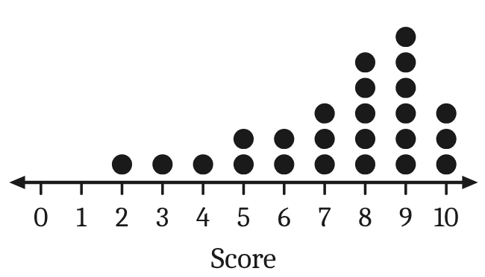
3 |  |  | 1
  The stem-and-leaf plot shows the ages of the 15 people in a yoga class. What is the median age? | 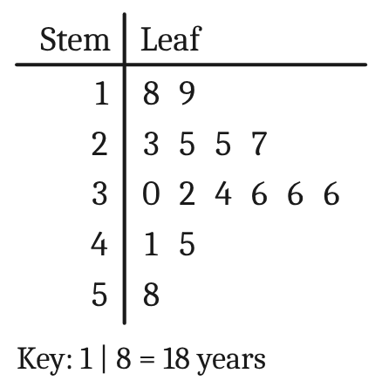
    A. 30 | B. 31 | C. 32 | D. 36
4 |  |  | 1
  The histogram shows the number of people in each of 24 cars that arrived at a beach car park. What is the mode? | 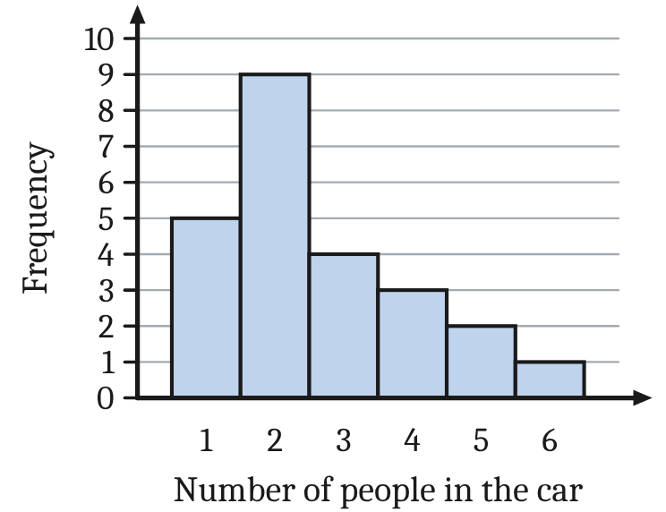
    A. 2 | B. 3.5 | C. 6 | D. 9
5 | A water polo team scored these numbers of goals in 10 games:  5, 7, 6, 8, 6, 21, 7, 5, 6, 8  Which measure of centre changes the most if the outlier, 21, is removed? |  | 1
  A. The mode | B. The median
  C. The mean | D. All three change by the same amount

 | Section 1: Data (continued)
 | Short Answer:
 | Question | Working Out | Mark
Use this set of data for questions 6 to 9.
The numbers of laps swum by 10 students at swimming training were:
9, 15, 11, 12, 18, 12, 14, 10, 16, 13
6 | Find the mean.  Note: Mean = sum of the scores ÷ number of scores |  | 1
7 | Find the median. |  | 1
8 | Find the mode. |  | 1
9 | Find the range.  Note: Range = highest score − lowest score |  | 1
10 | Students were asked how many times they went to the beach last week.  a. Complete the table.  b. Find the mean number of visits, correct to 2 decimal places.  c. Find the median number of visits.  d. Find the range.  Note: Mean = total of f × x ÷ total frequency  Range = highest score − lowest score | a.  b.  c.  d. | 1  1  1  1
  Visits (x) | Frequency (f) | f × x
  0 | 2
  1 | 6
  2 | 8
  3 | 5
  4 | 3
  5 | 2
  Total

 | Section 1: Data (continued)
 | Question | Working Out | Mark
11 | The delivery times (in minutes) of 10 orders from each of two pizza shops are shown below.
  Pete’s Pizza | 18 | 25 | 32 | 21 | 27 | 35 | 29 | 24 | 41 | 26
  Pizza Point | 15 | 22 | 19 | 28 | 17 | 23 | 16 | 30 | 21 | 18
a | Draw an ordered back-to-back stem-and-leaf plot of the data. Include a key. |  | 2
b | Find the median delivery time for each shop. |  | 1
c | Which shop delivers faster? Give a reason. |  | 1

 | Section 1: Data (continued)
 | Worded Problems:
 | Question | Working Out | Mark
12 | A surf shop has 10 employees, including the manager. Their weekly wages are:  $860, $920, $780, $1050, $840,  $3600, $900, $880, $760, $950  Note: Mean = sum of the scores ÷ number of scores
a | Find the mean weekly wage. |  | 1
b | Find the median weekly wage. |  | 1
c | The manager earns $3600. Find the mean weekly wage of the other 9 employees, correct to the nearest cent. |  | 1
d | Which measure, the mean or the median, better describes the typical weekly wage at this shop? Give a reason. |  | 1

 | Section 1: Data (continued)
 | Question | Working Out | Mark
13
  The Kestrels and the Tigers are two netball teams. The back-to-back stem-and-leaf plot shows the number of goals each team scored in its 12 games this season.  Note: Mean = sum of the scores ÷ number of scores  Note: Range = highest score − lowest score | 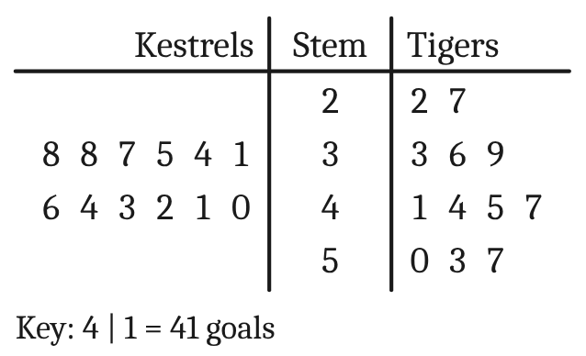
a | Find the mean number of goals for each team, correct to 1 decimal place. |  | 1
b | Find the median number of goals for each team. |  | 1
c | Which team usually scores more goals? Give a reason. |  | 1
d | Which team is more consistent? Use the range of each team to explain. |  | 1
 | Total |  | /25

 | Section 2: Surface area and volume
 | Multiple Choice: |  | Mark
1 | A rainwater tank holds 4.6 kL of water. How many litres is this? |  | 1
  A. 460 L | B. 46 000 L | C. 4600 L | D. 0.0046 L
2 |  |  | 1
  The scale on this measuring cylinder is shown.  What is the absolute error of a reading taken with this measuring cylinder?  Note: absolute error = ½ × precision (the smallest marked unit on the scale) | 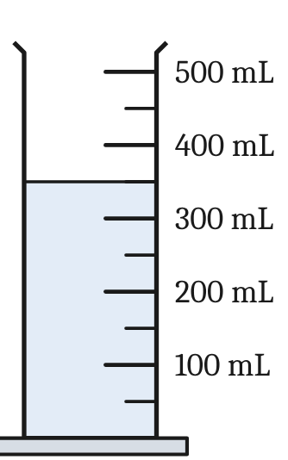
    A. ±25 mL | B. ±50 mL | C. ±100 mL | D. ±0.5 mL
3 |  |  | 1
  What is the area of this parallelogram?  Note: Area of a parallelogram: A = bh | 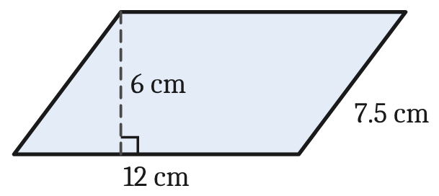
    A. 90 cm² | B. 36 cm² | C. 39 cm² | D. 72 cm²
4 |  |  | 1
  What is the area of this kite?  Note: Area of a kite: A = ½xy (x and y are the diagonals) | 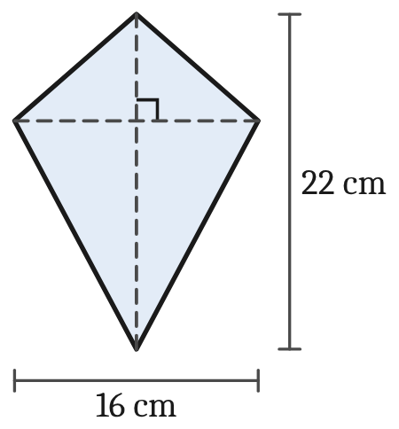
    A. 352 cm² | B. 176 cm² | C. 88 cm² | D. 38 cm²
5 |  |  | 1
  A photo frame is a 30 cm by 25 cm rectangle with a 20 cm by 15 cm hole for the photo.  What is the area of the frame (the shaded part)?  Note: Area of a rectangle: A = lb | 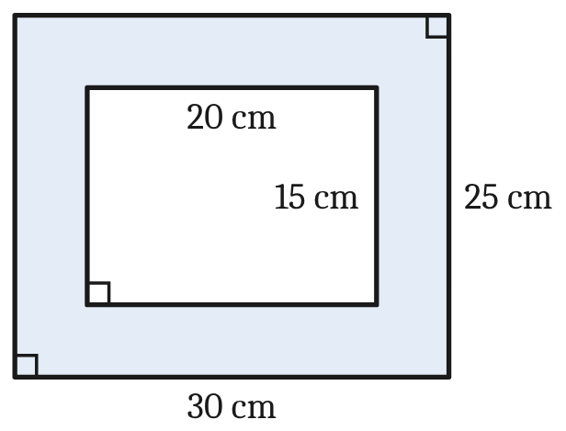
    A. 750 cm² | B. 1050 cm² | C. 450 cm² | D. 100 cm²

 | Section 2: Surface area and volume (continued)
 | Short Answer:
 | Question | Working Out | Mark
6 | Find the perimeter of this shape.  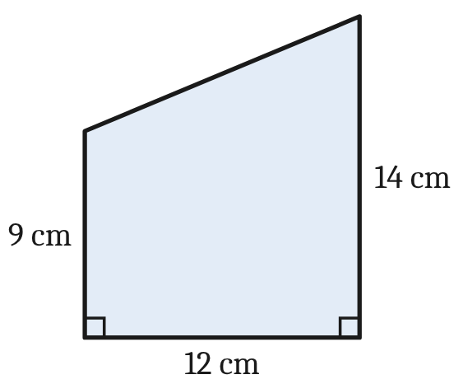  Note: Pythagoras’ theorem: c² = a² + b² |  | 2
7 | Find the area of this shape.  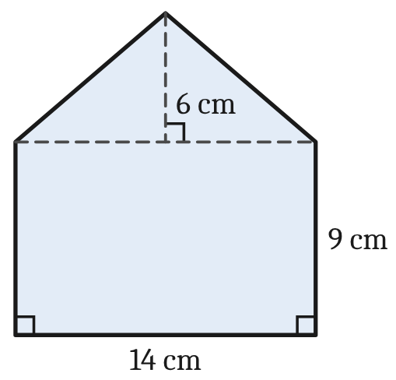  Note: Area of a rectangle: A = lb  Note: Area of a triangle: A = ½bh |  | 3
8 | A storage tub is a rectangular prism with no lid (it is open at the top). Find the surface area of the tub.  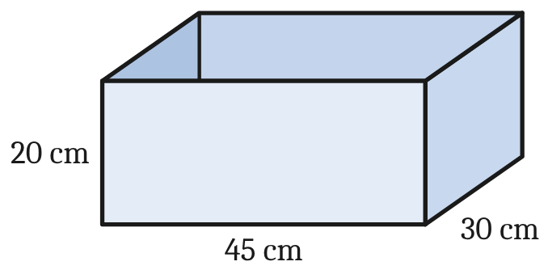  Note: Surface area = the total area of the faces; area of a rectangle: A = lb |  | 2

 | Section 2: Surface area and volume (continued)
 | Question | Working Out | Mark
9 | This closed cylinder has a diameter of 12 cm and a height of 15 cm.  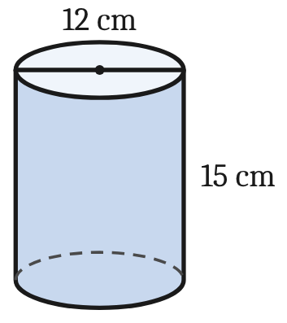  a. Find its volume, correct to 1 decimal place.  b. Find its surface area, correct to 1 decimal place.  Note: Volume: V = πr²h  Note: Surface area: SA = 2πr² + 2πrh | a.  b. | 2  2
 | Worded Problems:
 | Question | Working Out | Mark
10
  The plan shows an L-shaped lawn at a primary school. All of the corners are right angles.  Note: Area of a rectangle: A = lb | 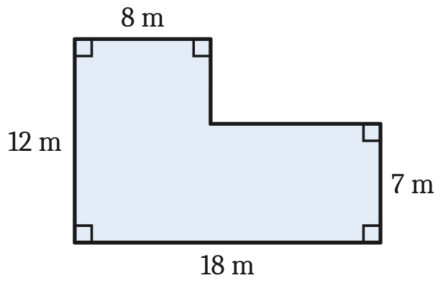
a | Garden edging is laid around the outside of the lawn. How many metres of edging are needed? |  | 1
b | Find the area of the lawn. |  | 2
c | New turf costs $12.40 per square metre. Find the cost of the turf for the whole lawn. |  | 1

 | Section 2: Surface area and volume (continued)
 | Question | Working Out | Mark
11
  A farmer’s water trough is a prism 150 cm long, open at the top. Its end is a trapezium with the measurements shown. | 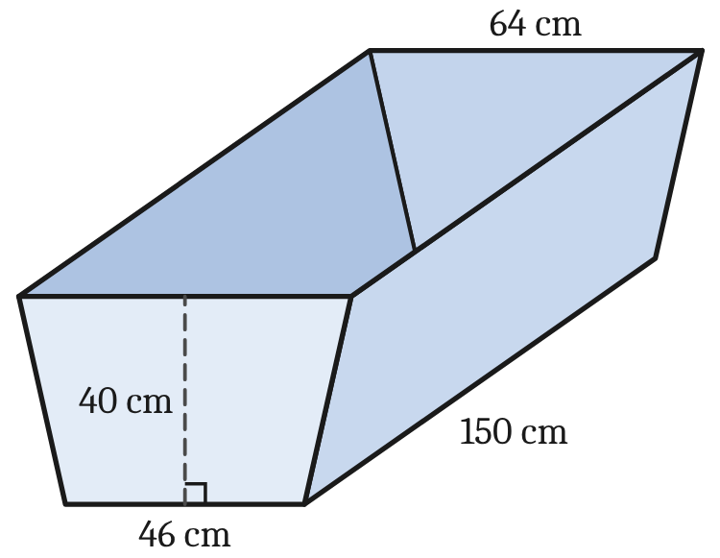
a | Find the area of the trapezium-shaped end of the trough.  Note: Trapezium: A = ½h(a + b) |  | 2
b | Find the volume of the trough in cm³.  Note: Volume of a prism: V = A × l  (A = area of the end, l = length of the prism) |  | 1
c | How many litres of water does the trough hold when it is full?  Note: 1 L = 1000 cm³ |  | 1
 | Total |  | /24

 | Section 3: Mixed Topics (Chapters 1–8)
 | Multiple Choice: |  | Mark
1 | If a = 5 and b = 3, evaluate 2a² − b. |  | 1
  A. 7 | B. 17 | C. 47 | D. 97
2 |  |  | 1
  Find the value of x. Select the closest answer.  Note: Pythagoras’ theorem: c² = a² + b² | 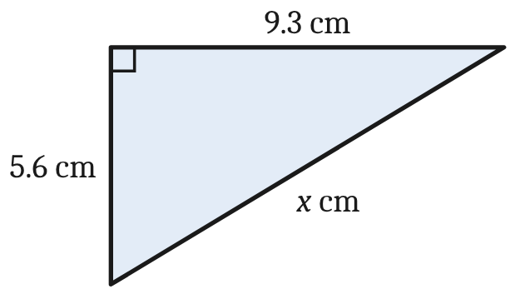
    A. 14.9 | B. 10.9 | C. 7.4 | D. 3.7
3 | A skateboard is marked at $145. In a sale it is discounted by 15%. What is the selling price? |  | 1
  A. $166.75 | B. $130.00 | C. $123.25 | D. $21.75
4 | Simplify 4m⁶ × 3m². |  | 1
  A. 12m⁸ | B. 7m⁸ | C. 12m¹² | D. 12m⁴
5 | Ella is a nurse. She earns an annual salary of $81 640. How much is she paid per fortnight?  Note: 1 year = 52 weeks = 26 fortnights = 12 months |  | 1
  A. $1570.00 | B. $3140.00 | C. $3401.67 | D. $6803.33
 | Short Answer:
 | Question | Working Out | Mark
6 | Expand and simplify:  3(4x − 5) − 2(x − 6) |  | 2
7 | Liam invests $7250 for 3 years at 4.2% p.a. simple interest. Calculate the interest he earns.  Note: Simple interest: I = Prn |  | 2

 | Section 3: Mixed Topics (Chapters 1–8) (continued)
 | Question | Working Out | Mark
8 | Find the value of x, correct to 2 decimal places.  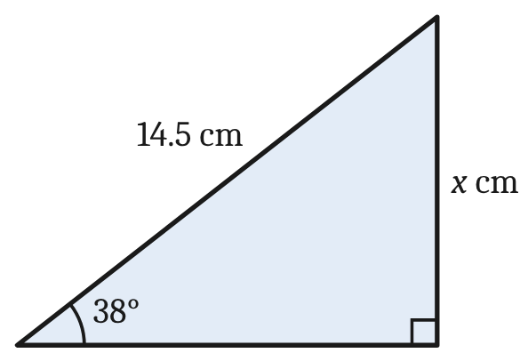  Note: sin θ = $\frac{\text{opp}}{\text{hyp}}$, cos θ = $\frac{\text{adj}}{\text{hyp}}$,  tan θ = $\frac{\text{opp}}{\text{adj}}$ |  | 2
9 | a. Write 0.000 724 in scientific notation.  b. Evaluate (4.8 × 10⁶) × (3.5 × 10⁻²), giving your answer in scientific notation. | a.  b. | 1  1
10 | Solve each equation.  a. 5x − 8 = 27  b. 7m − 2(m + 3) = 3m + 10 | a.  b. | 1  1

 | Section 3: Mixed Topics (Chapters 1–8) (continued)
 | Worded Problems:
 | Question | Working Out | Mark
11 | Mia works in a bakery. Her normal rate of pay is $26.80 per hour, and she is paid according to the award shown below.  Last week Mia worked 44 hours.
  Pay rate | Hours worked
  Normal rate | For 0 to 38 hours
  Time-and-a-half | For the next 3 hours
  Double time | For each hour after that
a | Calculate Mia’s pay for the first 38 hours. |  | 1
b | Calculate Mia’s total pay for the 44 hours. |  | 2

 | Section 3: Mixed Topics (Chapters 1–8) (continued)
 | Question | Working Out | Mark
12
  A ladder 5.2 m long leans against a vertical wall. The foot of the ladder is 1.6 m from the wall, on level ground.  Note: Pythagoras’ theorem: c² = a² + b²  Note: sin θ = $\frac{\text{opp}}{\text{hyp}}$, cos θ = $\frac{\text{adj}}{\text{hyp}}$, tan θ = $\frac{\text{opp}}{\text{adj}}$ | 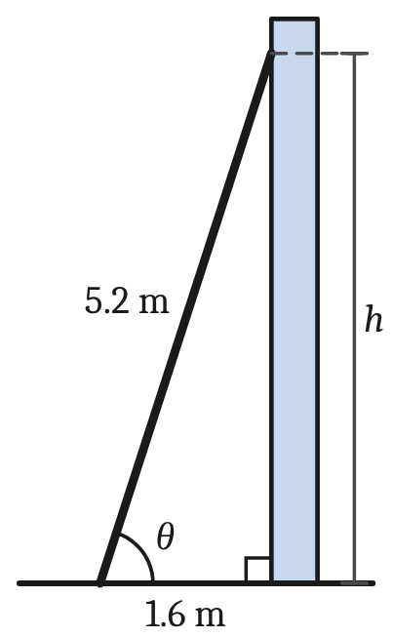
a | Find h, the height the ladder reaches up the wall, correct to 2 decimal places. |  | 1
b | Find the angle θ that the ladder makes with the ground, correct to the nearest degree. |  | 1
c | For safety, a ladder should make an angle of 75° with the ground. A longer ladder is placed at 75° so that its top reaches 6.5 m up the wall. How long is this ladder? Answer correct to 2 decimal places. |  | 1
 | Total |  | /21

